PLEASE STOP AND READ!!

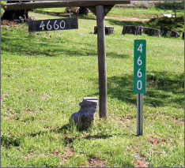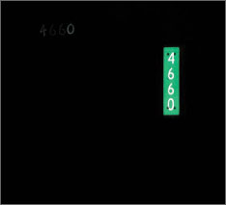

The Town of Oneida, Fire Department and First
Responders are requesting your help to remove
any high growth around the fire signs in case of an
emergency call.
ALSO, the removal of the sign that was once placed on Right-of-Way, shall be considered a violation by the property owner of the property identified by said sign. Any person who violates this ordinance shall be subject to a forfeit of not less than $100.00 or more than $500.00 together with the costs of prosecution per
ORDINANCE NO. 08-01
Dated July 16, 2008

